Network type: Peer to peer network

Characteristics:

* "peers" are computer systems which are connected to each other via the Internet.
* Files can be shared directly between systems on the network without the need of a central server.
* In other words, each computer on a P2P network becomes a file server as well as a client.

Assumptions about P2P:What defines important nodes? What separates influential nodes from non-influential ones- where does the variance occur?

* Seeders are more important- almost all nodes are seeders except a few.
* Nodes who seed many files will be connected to many different nodes (i.e. have higher degree?)
* Influential nodes are likely to have relatively higher degree than their neighbors ( for example someone who seeds anime, movies, music and games is supposed to have higher degree than its neighbors who seed only anime or movies) (i.e. have higher leverage?)
* Nodes that seed many files will also be closer to other nodes as they are more likely to be directly connected to more nodes (i.e. have higher closeness?)
* nodes adjacent /close to influential nodes can be expected to be in the same component as the influential node, as they will also share parts of the same files with each other. Hence density of the components will be higher if it contains 1 or more influential nodes, hence DMNC should be a factor.
* Nodes that are connected to influential node(s) are also crucial in file sharing as they incr

Results:

Peer-to-peer (P2P) networks are networks in which all nodes have the possibility of being connected to each other. This is due to the nature of the network, as edges are formed between nodes based on the availability of files and file segments. Users of P2P networks often share all kinds of files in these networks, hence it is one big community where all nodes can potentially connect to each other, rather than small cliques or closely connected communities.

Correlation plot:

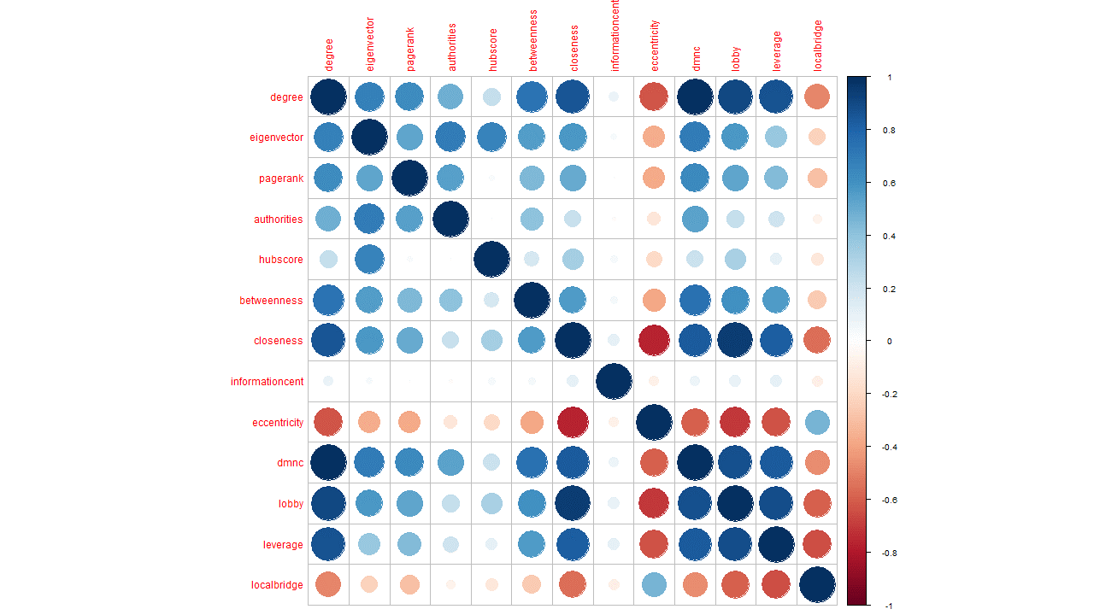

From the correlation matrix it can be seen that, degree and DMNC are strongly positively correlated, while closeness and lobby index are also strongly positively correlated. On the other hand eccentricity is strongly negatively correlated to both closeness and lobby. This makes sense as nodes that have more files to share will have higher degree and hence be a part of a denser community structure. Nodes that have higher closeness value can be thought of as a more active node in the network which is supplying more files compared to others, hence it should also have higher lobby index as it has a bigger probability of having strongly connected neighbors.

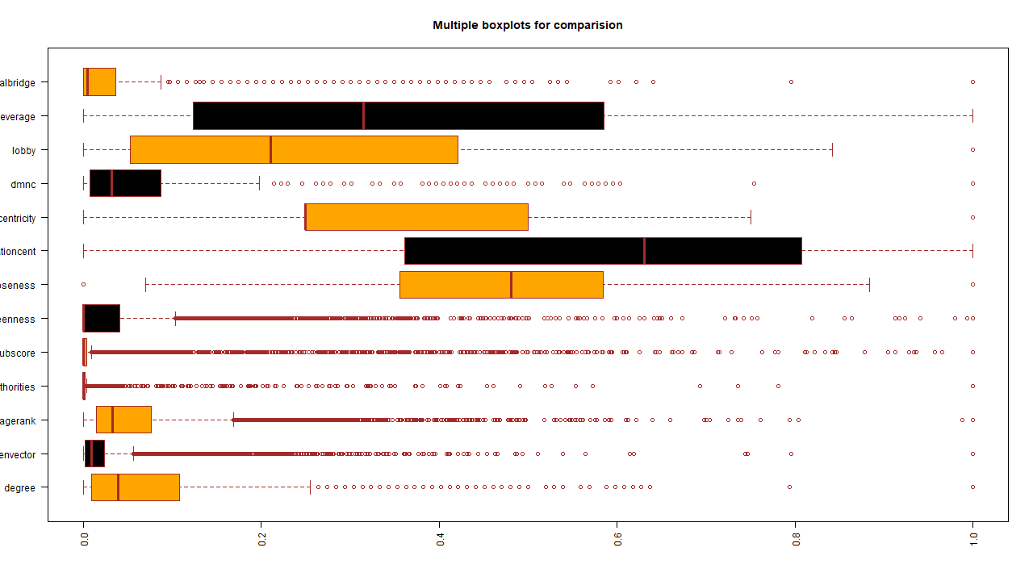

The boxplot shows the distributions of the variables. It is quite evident that most of the variables are skewed, and only closeness seems to have a somewhat normal distribution. Eccentricity is heavily right skewed as the values are mostly 0.25 and 0.5 while a few are 0 and 0.75. As these are discrete values they are not well represented in the box plot. Hubscore and Authority clearly have very similar distributions which makes sense considering they are derived using almost similar formulae. Degree, DMNC and pagerank have similar distributions. (*Didn’t include the exact numbers i.e. range but can be included obviously)*

*m1_all_var13<-ncentrality*

*m2_without_dg_var12<-within(ncentrality, rm(degree))*

*m3_without_comm_var7<-within(ncentrality, rm(informationcent,eccentricity,dmnc,lobby,leverage,localbridge))*

*m4_without_nodes_var6<-within(ncentrality, rm(degree,eigenvector,pagerank,authorities,hubscore,betweenness,closeness))*

*m5_without_ranks_var9<-within(ncentrality, rm(eigenvector,pagerank,authorities,hubscore))*

*m6_without_dist_var9<-within(ncentrality, rm(betweenness,closeness,informationcent,eccentricity))*

*m7_mix_match1_var6<-within(ncentrality, rm(eigenvector,closeness,informationcent,dmnc,lobby,leverage,localbridge))*

*m8_mix_match2_var6<-within(ncentrality, rm(degree,authorities,hubscore,betweenness,informationcent,eccentricity,leverage))*

*m9_mix_match3_var6<-within(ncentrality, rm(closeness,eigenvector,authorities,hubscore,betweenness,leverage,informationcent))*

*m1<-m1_all_var13*

*m2<-m2_without_dg_var12*

*m3<-m3_without_comm_var7*

*m4<-m4_without_nodes_var6*

*m5<-m5_without_ranks_var9*

*m6<-m6_without_dist_var9*

*m7<-m7_mix_match1_var6*

*m8<-m8_mix_match2_var6*

*m9<-m9_mix_match3_var6*

PCA:

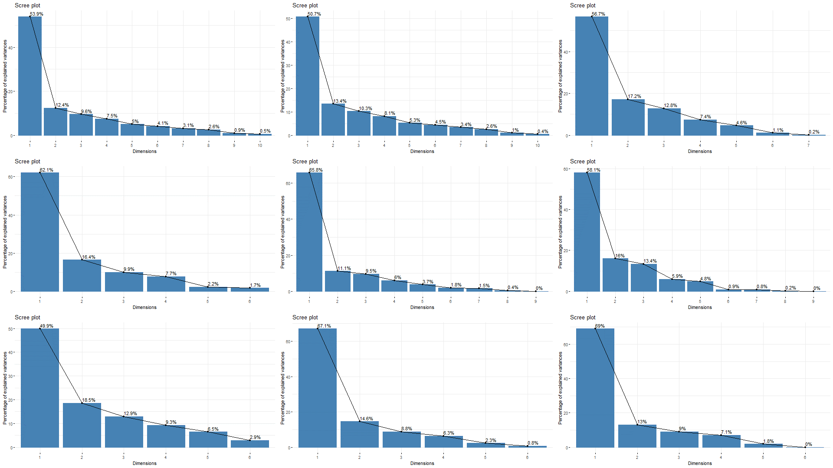

Figure 1 main model

In the main model, the first principal component shows about 53.9% variation, while the first 2 principal components shows about 66.3% variation and finally, taking the first three principal components together capture about 76% variance of the dataset.

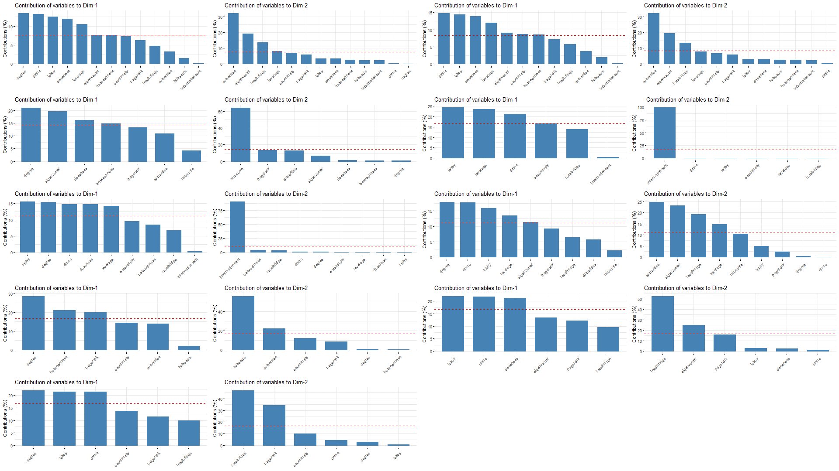

From the dimension contribution plots it can be seen that Degree, DMNC, Lobby, Closeness and leverage are the more significant factors contributing to principal component 1. In principal component 2, authorities, eigenvector and local bridging centrality contributes more.

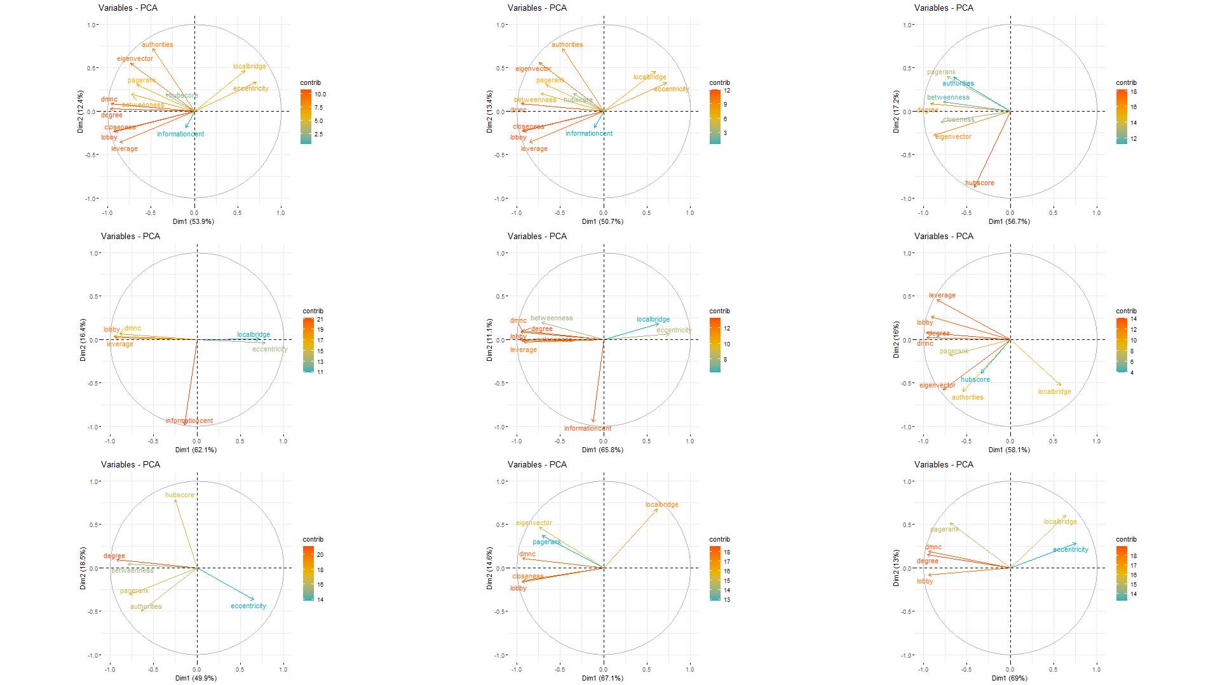

From the cos2 contribution plot it can be seen that the principal component 1 captures the most variation of Degree, DMNC, Lobby, Closeness and leverage while principle component 2 captures most variation of authorities, eigenvector and local bridging centrality which is consistent with the dimension contribution plots. The length and color of the variable signifies the importance/contribution of the variables, and hence in the main model degree, DMNC, lobby, closeness, leverage, eigenvector and authorities contribute the most.

*I’m supposed to explain why this makes sense, but I honestly don’t get why this makes sense, I feel like it’ll be better explained in the ablation study*

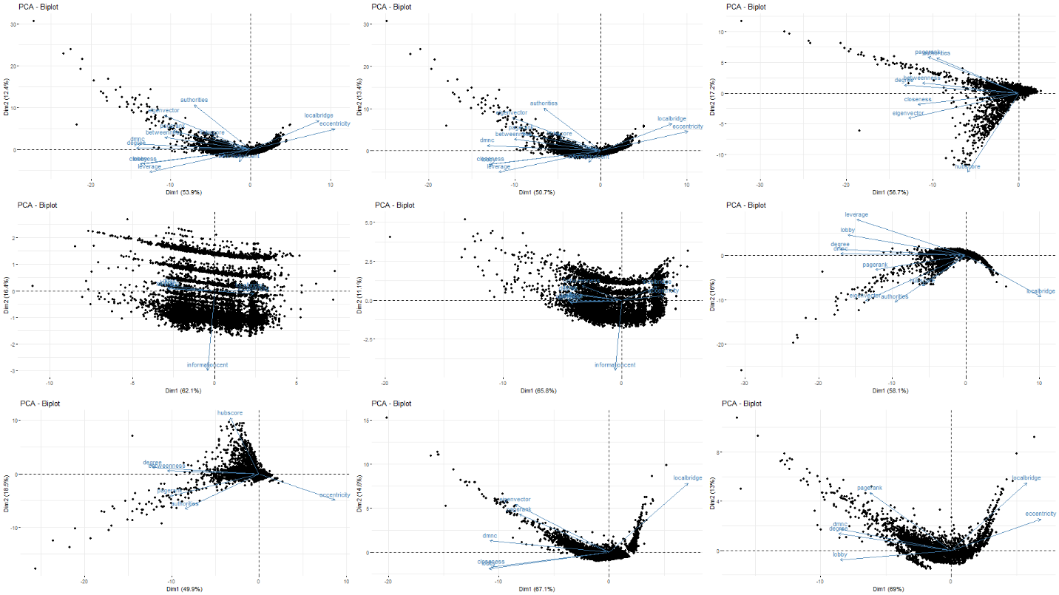

In the biplot, it can be seen that most data points are concentrated around the center, in a range of about -5 to 5 in PC1 and -2.5 to 5 in PC2. This proves our assumption that P2P networks do not contain many small cliques, as a big clique indicates many nodes have similar centrality values and hence are projected in similar manners on the principal components axes. However, some points seem to be away from the big cluster. These points can be assumed to be from nodes which shared files of a specific topic, or did not share as much as the others, hence they are isolated.

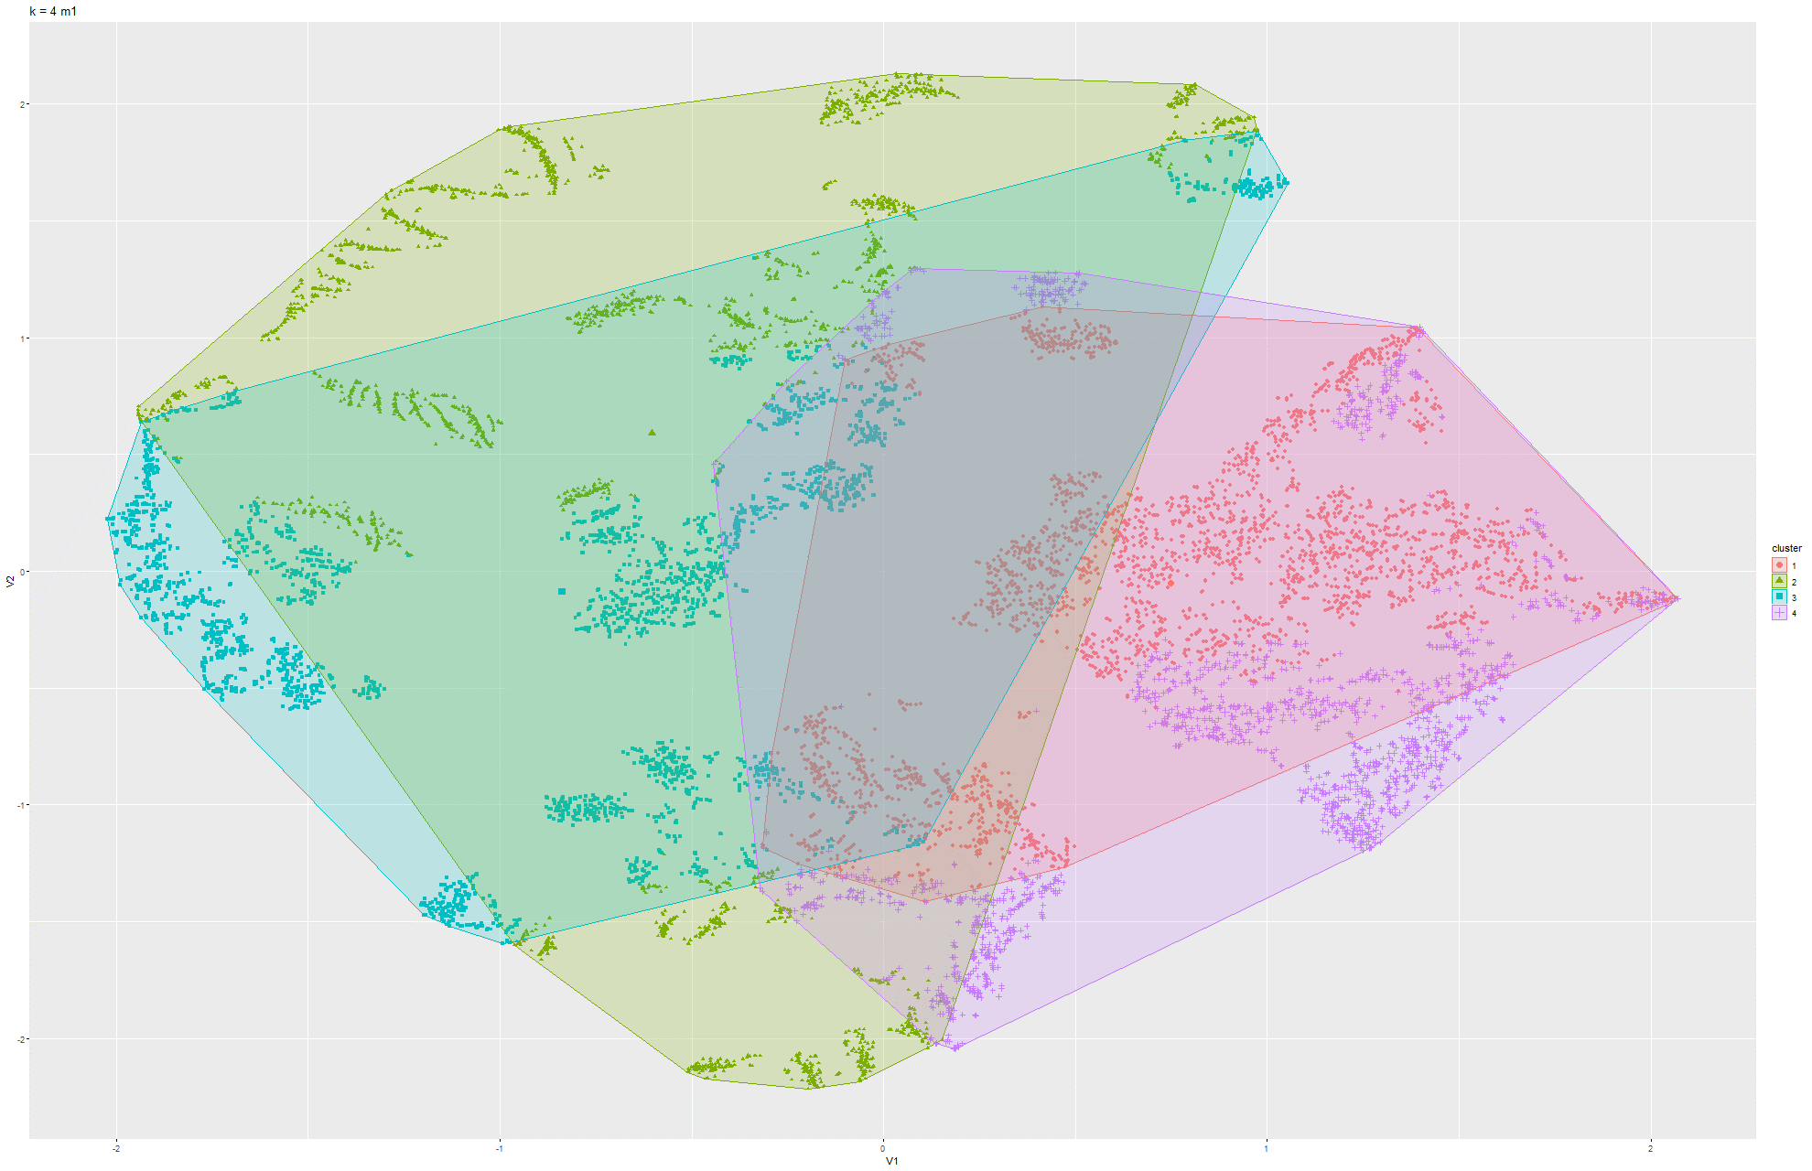

The above conclusion is farther supported by the t-SNE plot. It can be seen that most clusters overlap with each other, which indicates that it is the big cluster found in the PCA biplot. This overlap signifies the similarity of the data points’ centrality values even though they are expressed in reduced dimensions The parts that do not overlap are essentially the isolated nodes.

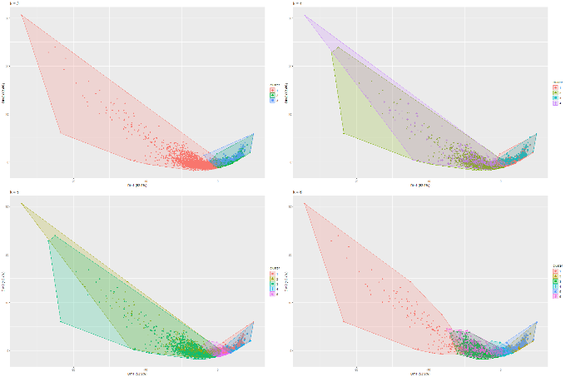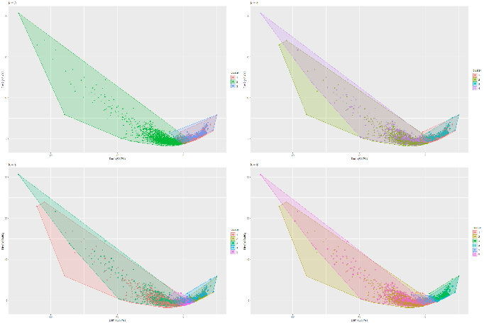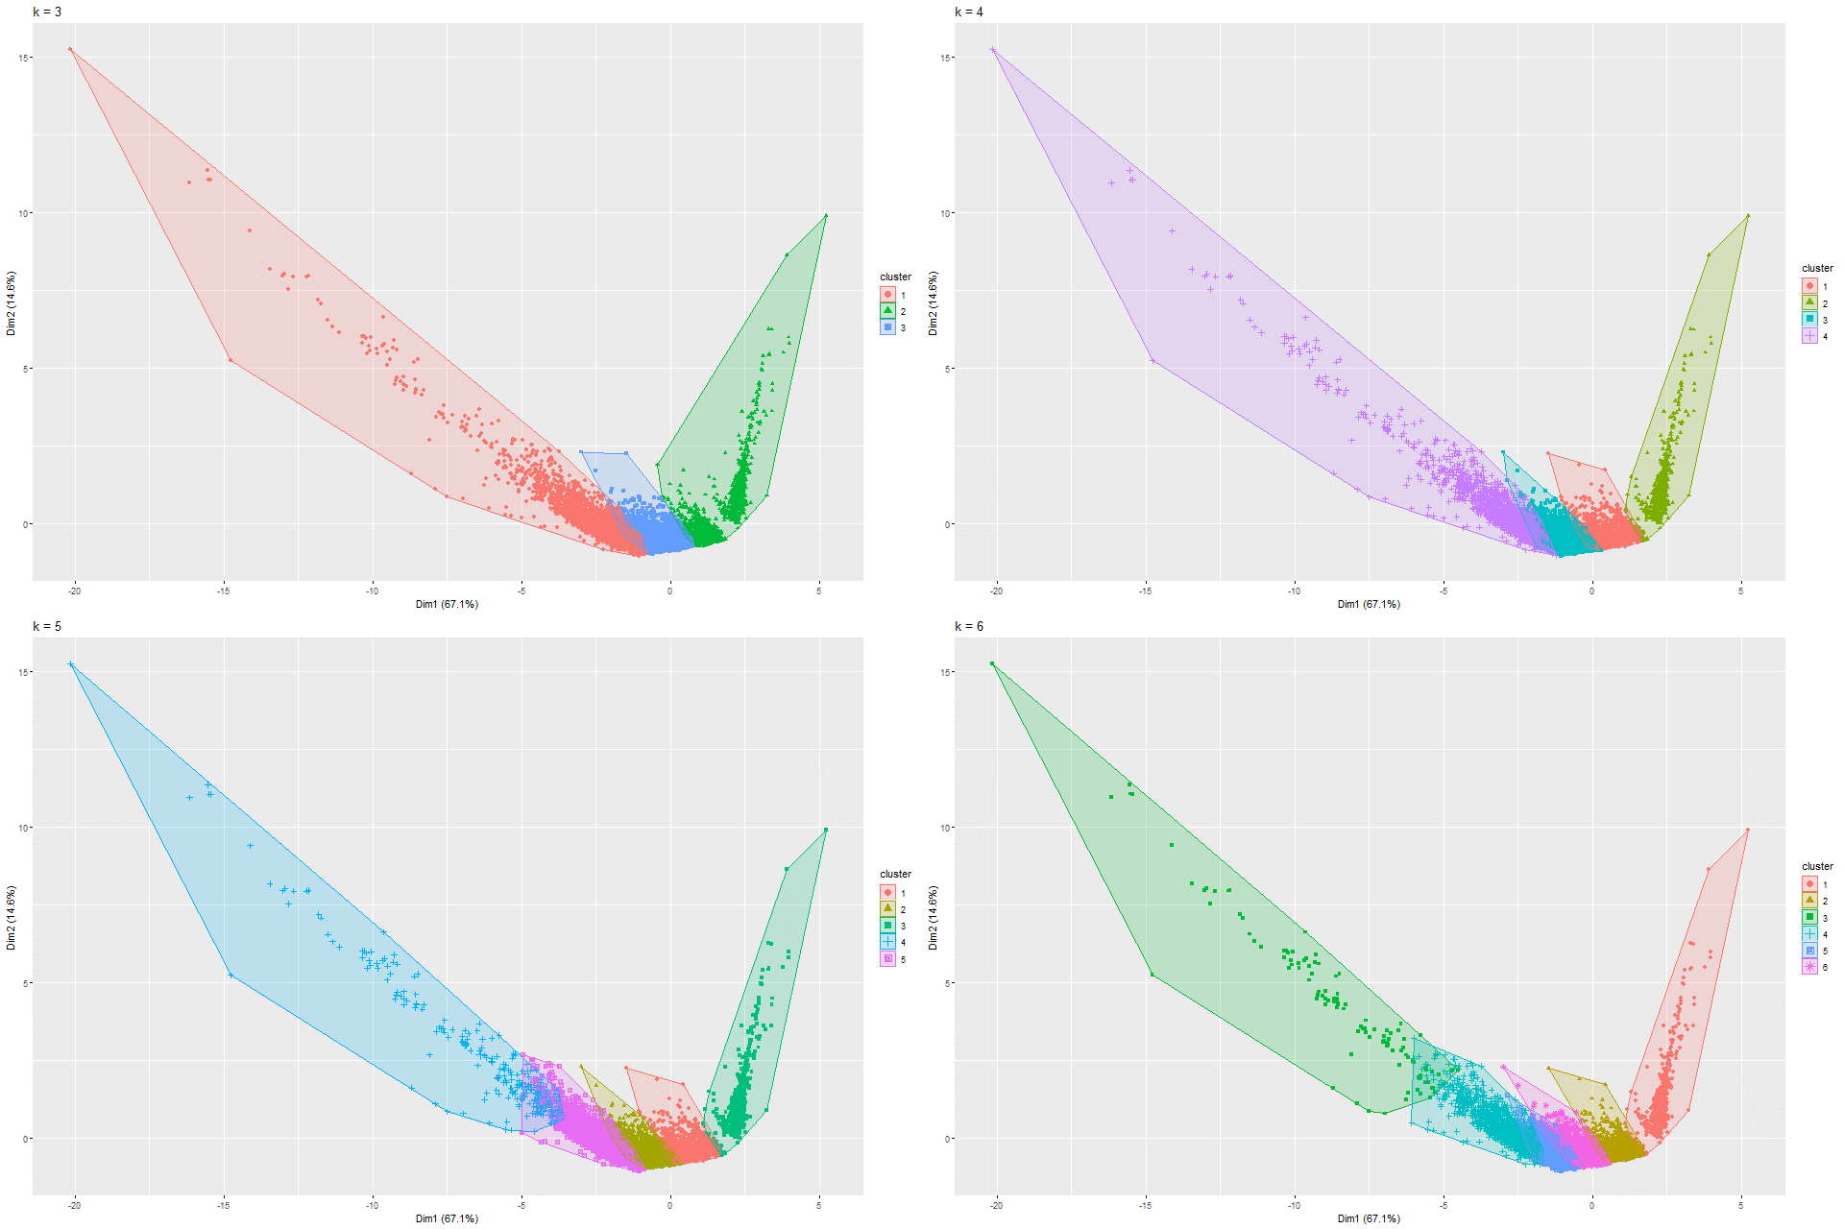

From the calinhara index it is seen that the optimal number of clusters for the main model is 4, for model 8 and model 9 is 3. Following this, it can be seen the main model gives 2 distinct clusters with minimal overlap. Model 8 has 2 overlapping clusters which cannot be used for distinguishing, but model 9 gives 3 distinct cluster with virtually no overlap. This can prove to be useful in distinguishing P2P networks.